**Name:** Joseph MUTANGANA

**Student ID:** 29061

**Course Name:** Computer Networks

**Instructor Name:** Joshua IRADUKUNDA

**Assignment Title:** Assignment#1

**Date:** Oct-11-2025



**NETWORK CONFIGURATION LAB**

**HANDS-ON LAB**



**Prepared by: Joseph MUTANGANA**

**IN CISCO PACKET TRACER**

**Table of Contents**

1. Introduction 1

2. Network Topology Design 1

3. IP Addressing Scheme and DHCP configuration 2

4. Routing between both LANs MASORO and GISHUSH 4

5. Remote Access Configuration (SSH) 5

6. NAT (PAT & Static NAT) Configuration 5

7. Port Security Configuration 6

8. HTTP Web Server Setup 7

9. Mail Server Configuration 7

10. Verification and Troubleshooting 8

11. Achieved Outcomes 10

12. Faced Challenges 11

Summary 12

# 1. Introduction

The purpose of the activity was to design, configure, and verify a **small-scale network** for two LANs — **Masoro** and **Gishushu** — connected through an **ISP router**, implementing core networking concepts used in real-world environments. The exercise focused on several key networking skills, including:

* **Subnetting and IP addressing**: Assigning unique IP subnets to different departments (IT, HR, Finance, CableNet, and WIFI-NET) and configuring routers and switches accordingly.
* **DHCP configuration**: Automating IP assignment for clients while excluding critical addresses such as the DNS server.
* **Routing**: Enabling communication between subnets using static routing.
* Etc..

# 2. Network Topology Design

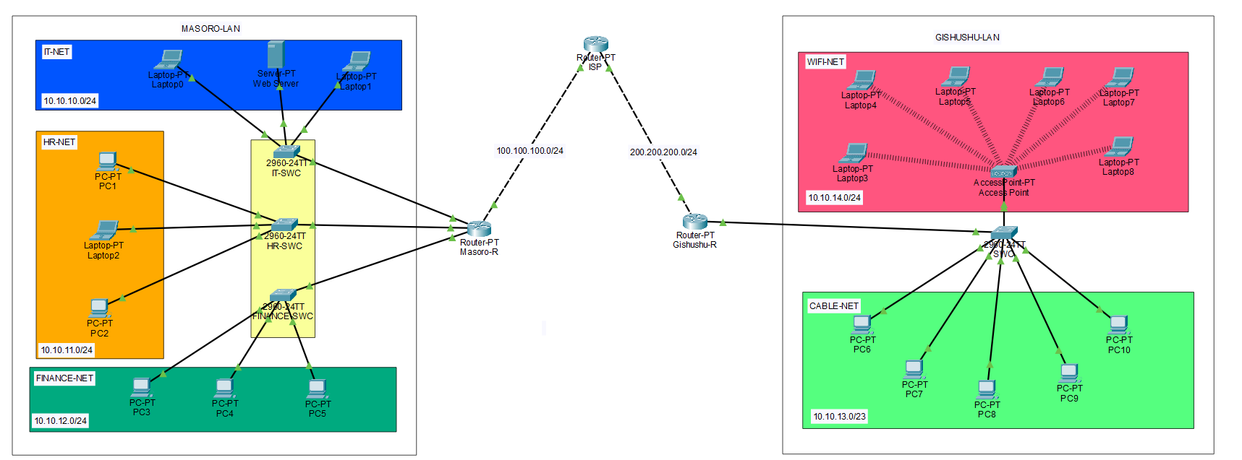

**Routers:** Used to make connect network and Acts as DHCP server

**Switch:** Connects multiple end devices

**End Devices (Server, PCs/Laptops):** Clients used in topology

# 3. IP Addressing Scheme and DHCP configuration

**Step 1:** Opened Router in Packet Tracer -> Opened CLI tab

**Step 2:** Enter Configuration global mode



**Step 3:** Excluded IP address



I only had one Static IP address on server, this command ensures that this IP address exclude from DHCP pool

**Step 4:** Create DHCP Pool

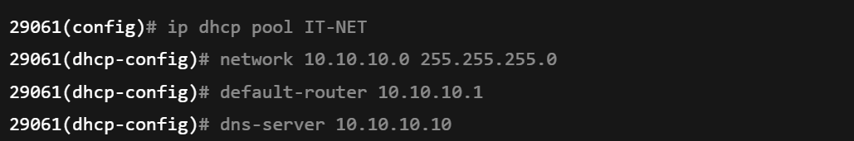

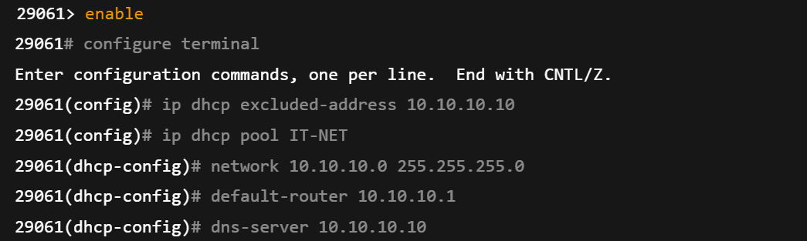

**Explanation of commands**

**enable:** this enable enter EXEC mode.

**configure terminal:** Enter global mode.

**ip dhcp exclude-address 10.10.10.10:** This tells dhcp pool to exclude that ip address.

**ip dhcp pool IT-NET:** This name of subnet you want pool address too.

**network:** Shows range of network and specify subnet mask

**default-router**: shows the gateway clients will use

**dns-server**: Sets domain name server

**Step 5:** Configure router interface

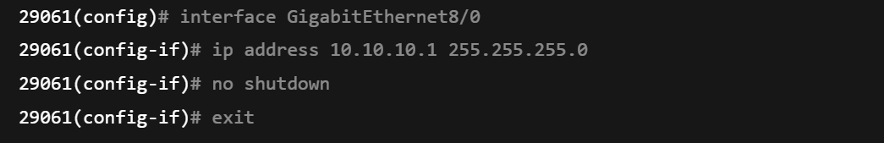

**On Clients laptops to get IP address Dynamically**

**Step 1: Open laptop device**

**Step 2:** Navigate to Desktop tab

**Step 3:** Select IP configuration

**Step 4:** Select DHCP

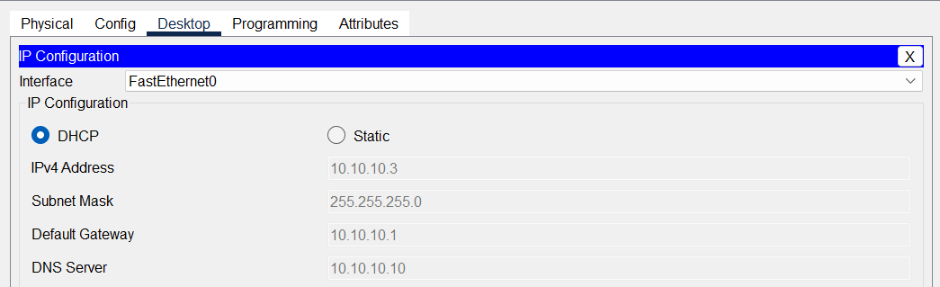

**Verification by using the command prompt**

**Step 1:** Open laptop device

**Step 2:** Navigate to Desktop tab

**Step 3:** Select command prompt

**Step 4:** type ipconfig or ipconfig /all

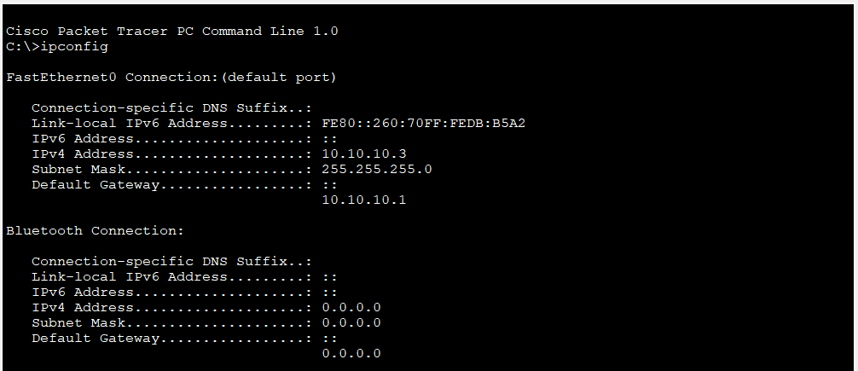

# 4. Routing between both LANs MASORO and GISHUSH

**Step 1:** Gave IP address to all subnets

**Step 2:** Assigned IP address on ISP

* Interface that face to MASORO-LAN

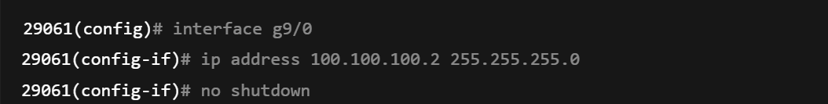

* Interface that face to GISHUSHU-LAN

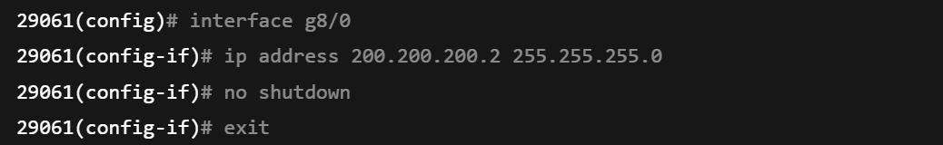

**Step 3:** Applied IP Route commands on GISHUSH-ROUTER

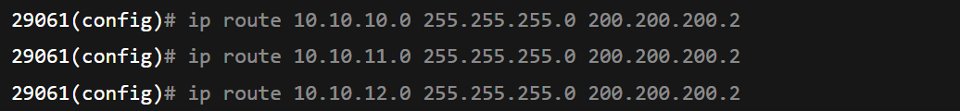

**Step 4:** Applied IP Route commands on MASORO-ROUTER



**Step 3:** Applied IP Route commands on ISP-ROUTER

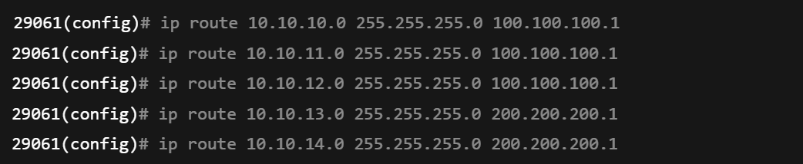

**ip route 10.10.10.0 255.255.255.0 200.200.200.2:** This tells Gishushu router to use 200.200.200.2 port faces to ICP to send traffic to network has this IP 10.10.10.0 in Masoro LAN, and vice versa.

# 5. Remote Access Configuration (SSH)

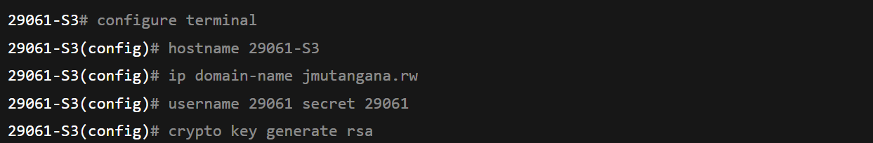

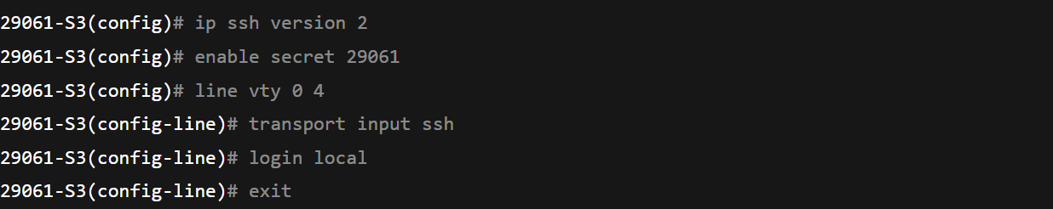

**Explanation of used Commands**

**ip domain-name jmutangana.rw:** defines the domain name for the router because SSH requires a domain to generate RSA encryption keys.

**Username:** Allows to set name of user who is using the device.

**Secrete:** Allows to set secrete for user when try log in.

**Crypto key generate rsa:** Generates RSA key used for SSH encryption.

**ip ssh version 2:** Enable SSH version 2

**line vty 0 4:** Enters configuration for virtual terminal lines 0 to 4

**transport input ssh:** Restrict remote to SSH only.

**login local:** tells the router/switch to use local username and password

# 6. NAT (PAT & Static NAT) Configuration

**Step 1: Define inside and Outside Interface**

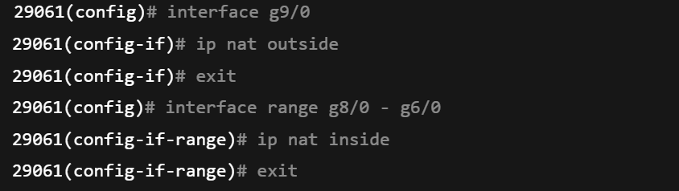

i**p nat outside:** Marks the WAN interface as outiside

**ip nat inside:** Marks the LAN interfaces as inside for NAT

**Step 2: Create an Access List to define inside Address**

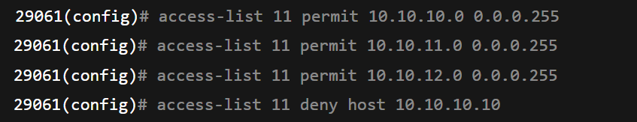

**Access-lists 11 permit 10.10.10.0 0.0.0255:** Defines which private IPs are allowed to be translated (Masoro’s LANs).

**access-lists 11 deny 10.10.10.10 0.0.0255:** Excludes the server IP from translation

**Step 3:** Apply NAT Overload (PAT)



**ip nat inside source list 11 interface g9/0 overload:** Tells the router to use the public IP of the outside interface (g9/0) for all internal users

**overload**: Enable PAT (Port Address Translation) many private IPs share one public IP, using different port numbers

7. Port Security Configuration

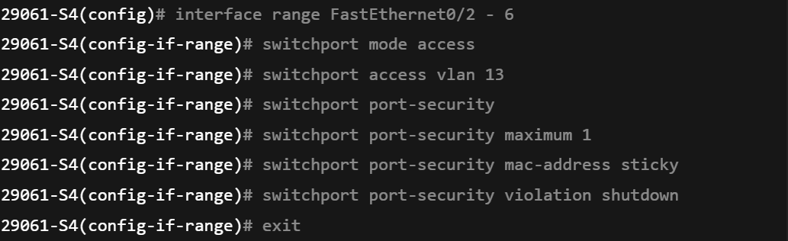

**Explanation of used commands**

**Interface range FastEthernet0/2 – 6:** This allows to apply configure same configuration on more than one port.

**switchport mode access:** forces port to work as access port.

**switchport access vlan 13:** Assign the port to vlan 13.

**switchport port-security:** Enables port security features on the port.

**switchport port-security maximum 1:** Limits each port to learn only one MAC addresss

**switchport port-security** **violation shutdown:** If violation occurs, the port goes into error.

**switchport port-security** **mac-address sticky**: Allows switch to store first connected MAC address in the running configuration

# 8. HTTP Web Server Setup

**Step 1:** Open Server

**Step 2:** Go to service tab

**Step 3:** Select HTTP on left side

**Step 4:** Enable on button on HTTP

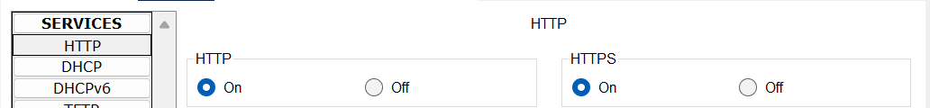

# 9. Mail Server Configuration

**Step 1:** Open Server

**Step 2:** Go to service tab

**Step 3**: Select EMAIL on left side

**Step 4:** Enable (on) button to open SMTP

**Step 5:** Enter Domain Name

**Step 6:** Click set button

**Step 7:** Create user by Entering username and password

**Step 8:** Click on Plus Button on right side

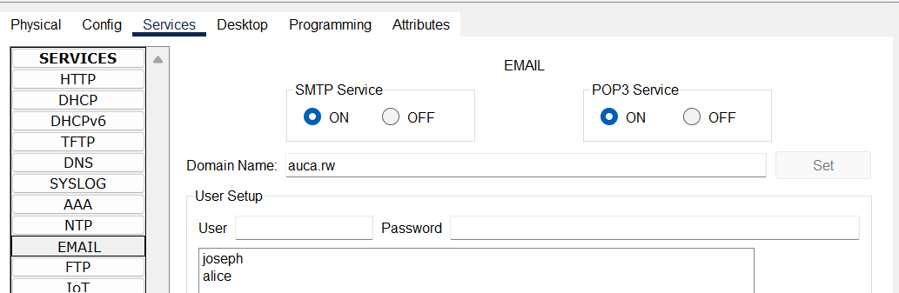

# 10. Verification and Troubleshooting

**1.Device information**



**2. Interface & IP Verification**



**3. Routing Verification**



**4.Nat Verification**



**5. DHCP Verification**



**6. Access Control List (ACL) Verification**

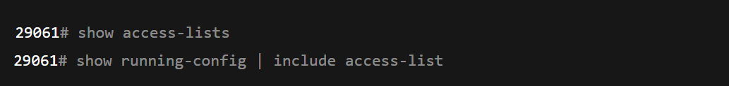

**7.Vlan & Trunk Verification**

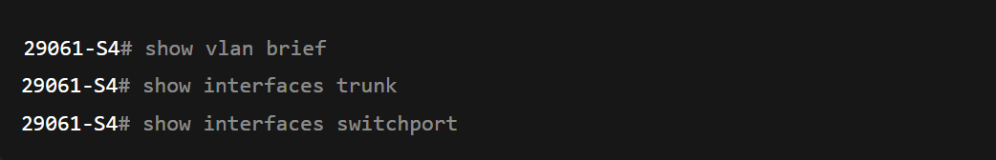

**8. Port Security Verification**



9.Connectivity Tests

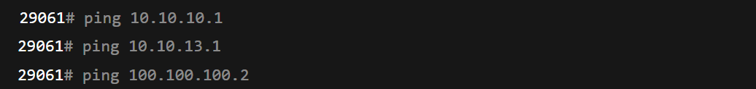

**10. Saving & Exiting**

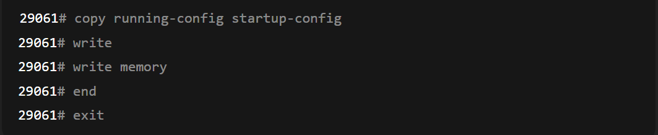

**Explanation of used Commands**

**show-running-config:** Displays current configuration

**show startup-config:** Display saved configuration

**show ip interface brief:** Gives summary of all interface

**show interfaces:** Displays detailed info about every interface

**show ip route:** Shows the routing table, including directly connected.

**show protocols:** Lists all interfaces with their assigned IPs and protocol status

**show ip nat translations:** Displays the active NAT translation

**show ip nat statistics:** Displays how many translations exist.

**show ip dhcp pool:** Shows all configured DHCP pools with details

**show ip dhcp binding:** Shows current IPs leased to clients

**show access-lists:** List all ACLs configure on the devices

**show vlan brief:** shows all vlan configure on the switch

**show interface trunk:** verifies interface are operating as trunks

**show interfaces switchport:** shows switchport mode

**show port-security:** This summarize port-security status for all interfaces.

**chow port-security interface fa0/1:** Display detailed port-security info for specific port

**ping:** used to test network reachability

**copy running-config startup-config:** Saves current configuration startup-config.

**write:** Saving configuration

**write memory:** Saving configuration

**end:** exiting any configuration mode.

**exit:** Exist the CLI

# 11. Achieved Outcomes

Connectivity Masoro ↔ Gishushu achieved.

Web server reachable on all clients.

Mail server operational across campuses.

Secure management via SSH.

VLANs, STP, and port security correctly configured.

# 12. Faced Challenges

In the **Gishushu LAN**, I initially struggled with assigning IP addresses to **WIFI-NET (10.10.14.0/24)** and **CABLE-NET (10.10.13.0/24)** because both networks were connected to the **same switch**, which in turn had only **one physical link to the router**. At first, I tried assigning only one IP address to the router port, but this did not allow both networks to communicate properly.

Later, I discovered the concept of **Router-on-a-Stick**, which allows a single physical router port to handle multiple IP subnets by creating **sub-interfaces**, each assigned to a specific VLAN. I configured the switch port connecting to the router in **trunk mode**, enabling it to carry traffic for multiple VLANs simultaneously. I then applied **NAT** on these sub-interfaces to allow the devices in both VLANs to access external networks.

Using this method, a single router port was able to serve multiple IP flows corresponding to their respective VLANs, resolving the connectivity issue and reinforcing my understanding of **inter-VLAN routing** and VLAN tagging.

**I corrected by following these steps**

**Step 1:** Configure sub-Interface

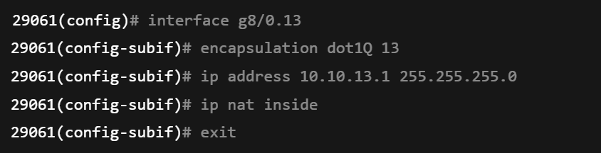

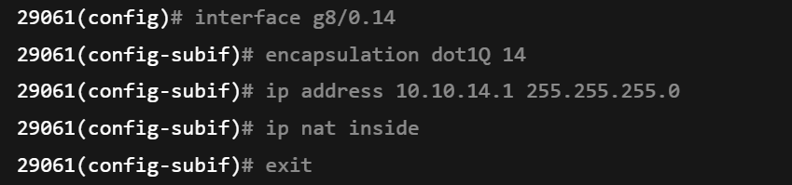

**Explanation of used Commands**

**Interface g8/0.13:** creates a sub-interface .13 on physical interface g8/0

**Interface g8/0.14:** creates a sub-interface .14 on physical interface g8/0

**Encapsulation dot13Q:**  Assigns VLA 13 to this sub-interface using 802.1Q trunking.

**Ip address 10.**10.13.1 255.255.255.0: Assigns IP address for CABLE-NET (VLAN 13)

**Ip nat inside:** Marks sub-interface as inside for NAT

**exit:** Exit from sub-interface

**Step 2:** Switch port Trunking

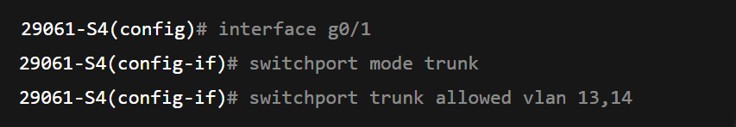

**Explanation of use commands**

**Interface g0/1:** entering the port connected to router

**switchport mode trunk**: Configure the switch port connectivity to router as trunk.

**switchport trunk allowed vlan 13,14:** Restrict the trunk to only VLAN 13 and VLAN 14

# Summary

During the activity, the following tasks were successfully completed:

1. **IP Addressing & Subnetting**:
   1. Masoro LAN: IT-NET (10.10.10.0/24), HR-NET (10.10.11.0/24), FINANCE-NET (10.10.12.0/24)
   2. Gishushu LAN: CABLE-NET (10.10.13.0/24), WIFI-NET (10.10.14.0/24)
   3. All subnets configured with mask 255.255.255.0, DNS server 10.10.10.10.
2. **DHCP Configuration**:
   1. Created pools for each subnet.
   2. Excluded critical IPs (like the DNS server).
   3. Configured default gateways and DNS settings for automated client IP assignment.
3. **Routing**: Static routing enabled on both Masoro and Gishushu routers to ensure inter-subnet communication and internet access via the ISP.
4. **VLANs & Trunking**:
   1. Configured VLANs on the S4 switch.
   2. Access ports assigned to appropriate VLANs.
   3. Trunk links set to carry multiple VLANs between switch and router.
5. **Port Security**:
   1. Applied to all access ports, limiting the number of MAC addresses per port.
   2. Sticky MAC addresses enabled and violation action set to shutdown.
6. **SSH Configuration**:
   1. Local users created and encrypted passwords configured.
   2. RSA keys generated, SSH version 2 enabled.
   3. VTY lines configured for SSH login only.
7. Used commands like show ip interface brief, show running-config, show vlan brief, show port-security, show ip nat translations, and ping to confirm network connectivity, security, and proper configuration.

**END.**